**Methods of Control**

In our soft glove rehabilitation project, we have chosen a PID control algorithm for precise motion regulation and pneumatic actuators to provide force for the hand exercises. The design is based on a framework from one article, while the method is adapted from another. The control of the glove is a critical aspect, and we evaluated two approaches: mirror rehabilitation and a dedicated application.

-Mirror Rehabilitation

Mirror rehabilitation involves using the glove on the unaffected hand to mirror movements to the affected hand. This method can help improve motor control through neural mirroring and enhance engagement by involving both hands. However, it requires bilateral use, which may not be suitable for all patients, and is less flexible in adapting to specific rehabilitation needs.

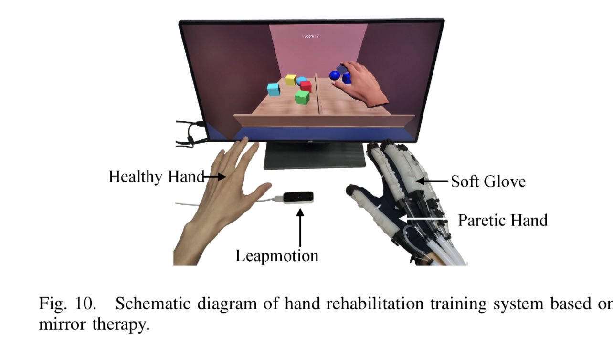

-Application

The alternative, a dedicated application, provides greater versatility. The application will have two main features: preset gestures for automatic movements and sliders to control each finger individually. This allows the therapist or patient to adjust exercises precisely according to the rehabilitation needs. The app can also deliver personalized routines, real-time feedback, and track progress. This approach is more accessible, adaptable, and can include engaging features like gamification. Although developing and maintaining the app may be complex, the benefits outweigh the challenges.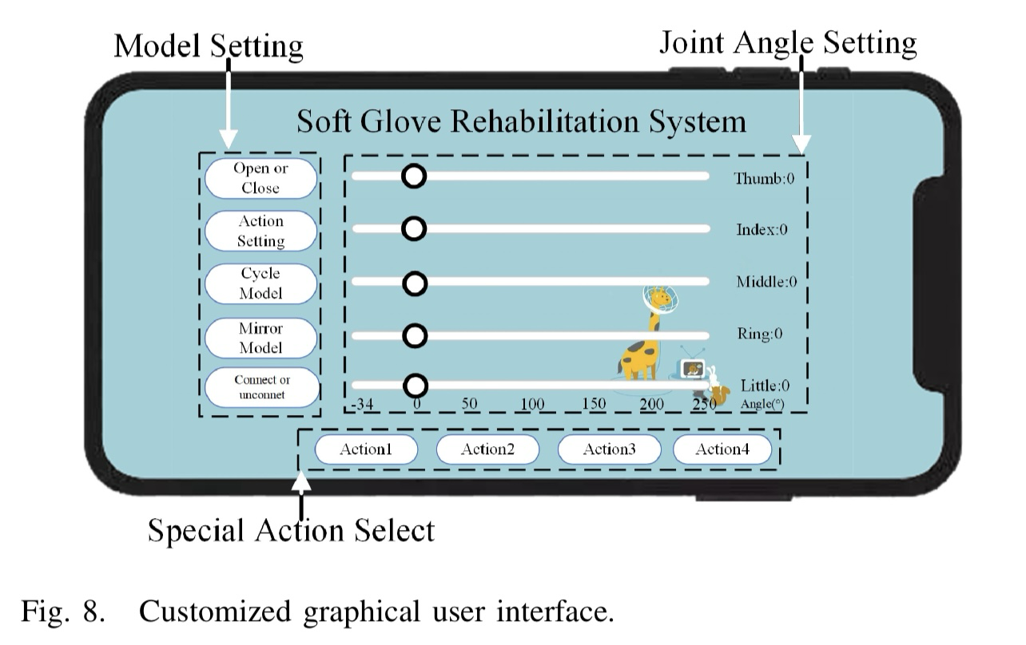

We believe the application is a better option because it offers customized control, adaptability, and engagement. Implementation can be achieved by designing an intuitive user interface for mobile devices that communicates with the glove via Bluetooth or Wi-Fi, allowing for real-time adjustments and tracking. This method offers more flexibility for patients and therapists alike, making it the preferred choice for effective rehabilitation.

**Pneumatic Actuator Components**

It had been concluded that the article “A Novel Wearable Soft Glove for Hand Rehabilitation and Assistive Grasping” seems to be the best to work with since it provides both abduction/adduction and flexion/extension (which other implementations do not provide) along with satisfactory hand rehabilitation and activities of daily living finger movements. Moreover, it does so at lower pressures than other implementations (at around 50 kPa at a maximum).

The components needed to implement the glove can be found in the following table:

|  |  |
| --- | --- |
| Part | Quantity |
| Bending Actuator (Dragon Skin 20 Silicone) | 5 |
| Rotating Actuator (Dragon Skin 20 Silicone) | 5 |
| Wax | 5 |
| Arduino Due/STM32 | 1 |
| Flexible Strain Sensor | 10 |
| Embedded Force Sensor | 10 |
| Solenoid Valve | 10 |
| Proportional Valve Module | 2 |
| Relay Group Module | 1 |
| Amplifier Circuit | 1 |
| Operational Amplifier | 2 |
| Tubes | 10 |
| DC power supply | 1 |
| 50 kPa Air Compressor | 1 |
| Velcro Glove | 1 |

**Flow Chart**

* **Mobile App Preset**
  + A mobile app feature could allow users to preset specific rehabilitation exercises or assistive grasping states.
  + The user selects a preset mode, and the app sends the configuration to the glove's control system via Bluetooth or Wi-Fi.
  + The app could store settings for various exercises (e.g., grip strength, finger flexion range) and transmit this information to the control system for automatic adjustment.

Feedback Loop

* The system receives real-time feedback from the sensors and makes continuous adjustments through the PID control system to ensure the glove functions smoothly

Control System Processing

* Hybrid PID Control Algorithm for adjusting Force and Position.
* Processes the sensor signals determining the appropriate response

Signal Transmission

* + Control signals are sent to the actuators (bending and rotating actuators), instructing them to move based on the desired input.

Actuator Response

* + Bending and rotating actuators inflate or deflate via pneumatic valves, adjusting finger flexion/extension and abduction/adduction motions.